**Pendo Security**

**Installation:**

##### Step 1 – We start by copying this to your index.html:

<script>

(function(apiKey){

(function(p,e,n,d,o){var v,w,x,y,z;o=p[d]=p[d]||{};o._q=o._q||[];

v=['initialize','identify','updateOptions','pageLoad','track'];for(w=0,x=v.length;w<x;++w)(function(m){

o[m]=o[m]||function(){o._q[m===v[0]?'unshift':'push']([m].concat([].slice.call(arguments,0)));};})(v[w]);

y=e.createElement(n);y.async=!0;y.src='https://cdn.pendo.io/agent/static/'+apiKey+'/pendo.js';

z=e.getElementsByTagName(n)[0];z.parentNode.insertBefore(y,z);})(window,document,'script','pendo');

})('dc8e5c8b-20be-4e68-7450-f5f20bec90a2');

</script>

**Note:** 'dc8e5c8b-20be-4e68-7450-f5f20bec90a2' is the API key.

##### Step 2 – Then, we add this once your users are logged in/authenticated. This function is used to fetch the visitor and accounts data.

##### pendo.initialize({

##### visitor: { id: <visitor-id-goes-here>

##### First name: <visitor-First name-goes-here>

##### Last name: <visitor-Last name-goes-here>

##### // *we can add any additional account level key-values here* },

##### account: { id: <account-id-goes-here>

##### Acc name: <visitor-Acc name-goes-here

##### // *we can add any additional account level key-values here* } });

##### Note: Pendo takes in only the parameters that has been mentioned in the function.

**Please refer the link for further details:**

<https://support.pendo.io/hc/en-us/sections/360003496292-Install>

**Data Collection:**

1. The only critical information that Pendo needs is a unique identifier for each visitor in your application. This unique identifier doesn't have to include any personally identifiable information for the user or the account. However, although not required, most Pendo customers do pass additional information, such as an email or account name, which makes tracking easier. Additionally, they may provide other demographic information to help build out segments.

2. The Pendo platform doesn't collect any user-entered text or information within form fields in your application. By default, it captures the names of fields, buttons, and other elements along with the application data, which simplifies tracking. However, no user-supplied information is included in this process.

**3. Raw Events:**

1. *Data Collection:* Once Pendo is installed in an application, it can indeed collect raw events whenever user interactions or events occur in the application. These raw events include various user actions like clicks, form submissions, page views, and custom events.
2. *Tagging:* While Pendo can collect raw events without explicit tagging, tagging is crucial for making sense of the collected data. By tagging pages or features, you are effectively defining and categorizing the events associated with those pages or features. This tagging allows Pendo to classify and analyze the events based on the tagged elements, making it easier to understand user behavior.
3. *Event Classification:* Without proper tagging, the raw events are less meaningful, and it can be challenging to determine which events correspond to specific actions or features in the application. Tagging helps provide context and structure to the data collected by Pendo.

**Note:** Having Google Tag Manager (GTM) is not designed to control the raw events collected by Pendo directly, it can be used to enhance your tracking, trigger custom events, and manage the data that you send to Pendo, allowing for greater customization and control over the events you track and how they are sent to Pendo. The exact implementation details will depend on your specific use case and the integration between GTM and Pendo.

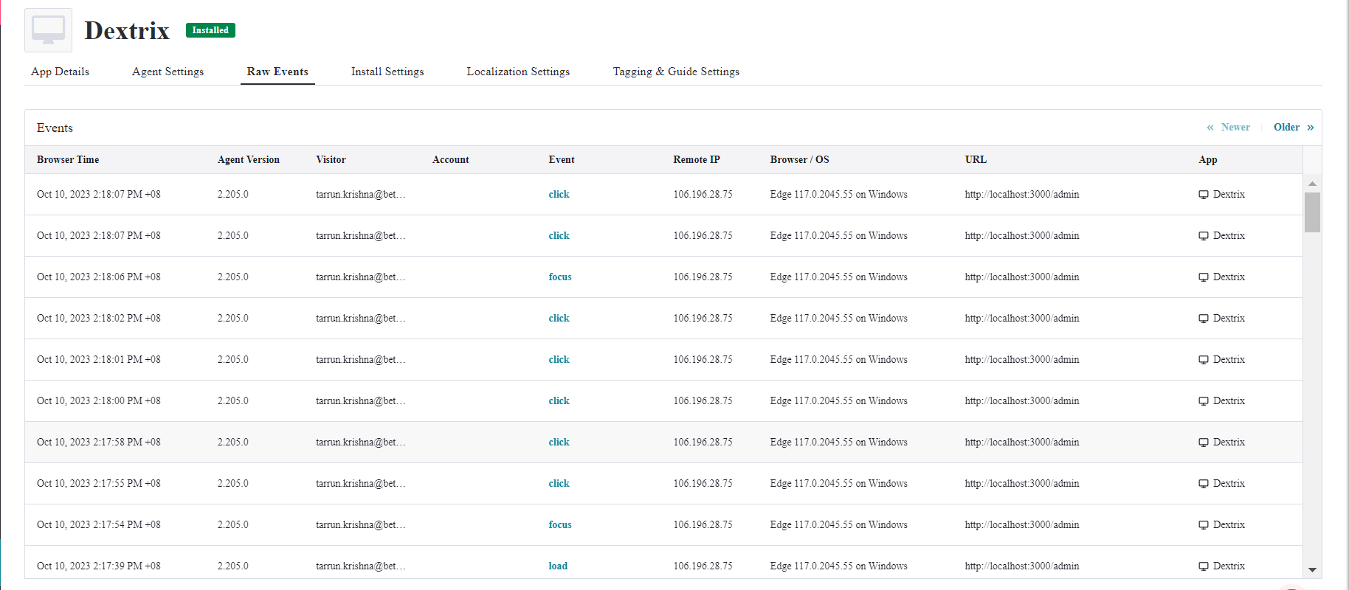

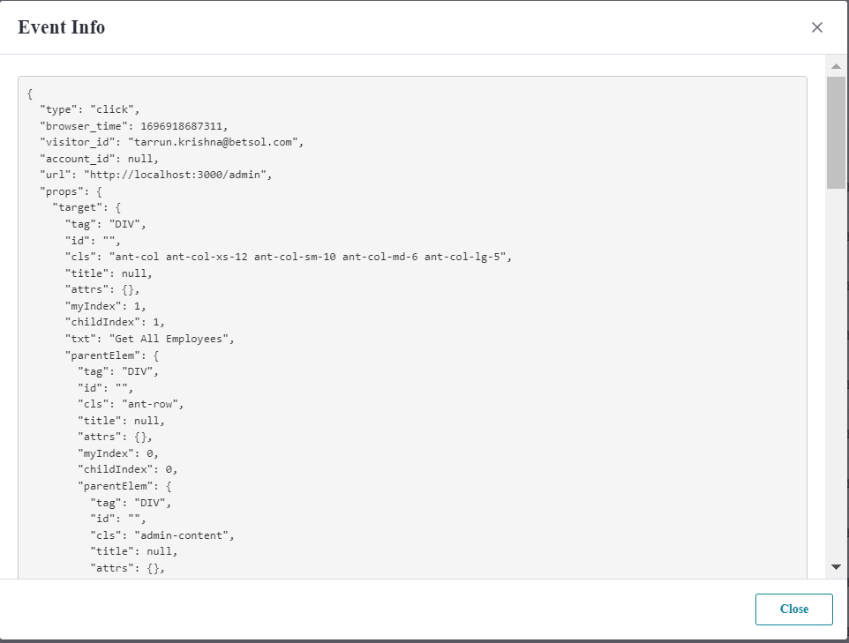The event is recorded in JSON format:

**Please refer the link for further details:**

<https://support.pendo.io/hc/en-us/articles/360031862372-Security-and-Privacy>

**Pendo Security:**

The provided information highlights the security and privacy measures that Pendo.io implements to protect user data and ensure data privacy. Here are some key points from the information provided:

**1. Data Encryption:** Pendo.io ensures data security by transmitting all application data over SSL/TLS, encrypting it, and storing it using AES-256 encryption. This helps protect user data during transmission and while it's stored within the platform.

**2. Data Separation:** Pendo.io employs techniques for logical separation and stores data for each customer using separate namespaces to prevent data co-mingling. This ensures that customer data remains isolated and private.

**3. Unique User Identifier:** The Pendo platform primarily requires a unique identifier for each user in your application. This identifier does not have to be personally identifiable information (PII). While additional information, such as email or account name, can be passed to Pendo for segmentation purposes, it is not mandatory.

**4. No User-Entered Text:** Pendo.io does not collect user-entered text or information within form fields in your application. The platform captures the names of fields, buttons, and other elements on pages for tracking purposes, but it does not capture user-supplied information. However, disabling all text capture is not recommended, as it may limit data analysis.

**5. Audits and Certifications:** Pendo undergoes SOC 2 Type 2 audits annually, covering Trust Services Principles, including Security, Availability, Processing Integrity, Confidentiality, and Privacy. The reports have been issued with no exceptions in related controls. Pendo also conducts third-party penetration testing twice per year.

**6. Google Cloud Services (GCS):** Pendo's application and data are hosted and stored in Google Cloud Services, which is SOC 2, SOC 3, ISO 27001, FISMA, and PCI compliant. GCS shares infrastructure with Google's primary services and undergoes multiple independent security audits annually.

**7. Authentication and 2-Factor Authentication (2FA):** Pendo provides two login mechanisms - internal authentication and authentication via Google Authenticator or another SAML Identity Provider (IdP). Using Google or another SAML IdP, users can set up and enforce 2-factor authentication for added security.

These security and privacy measures demonstrate Pendo.io's commitment to protecting user data and ensuring data privacy for its customers. Users and administrators have options for securing their accounts and data within the platform.

**Please refer the links for further details:**

<https://www.pendo.io/data-privacy-security/>

<https://pendo.trust.page/>

**Dataflow Diagram:**

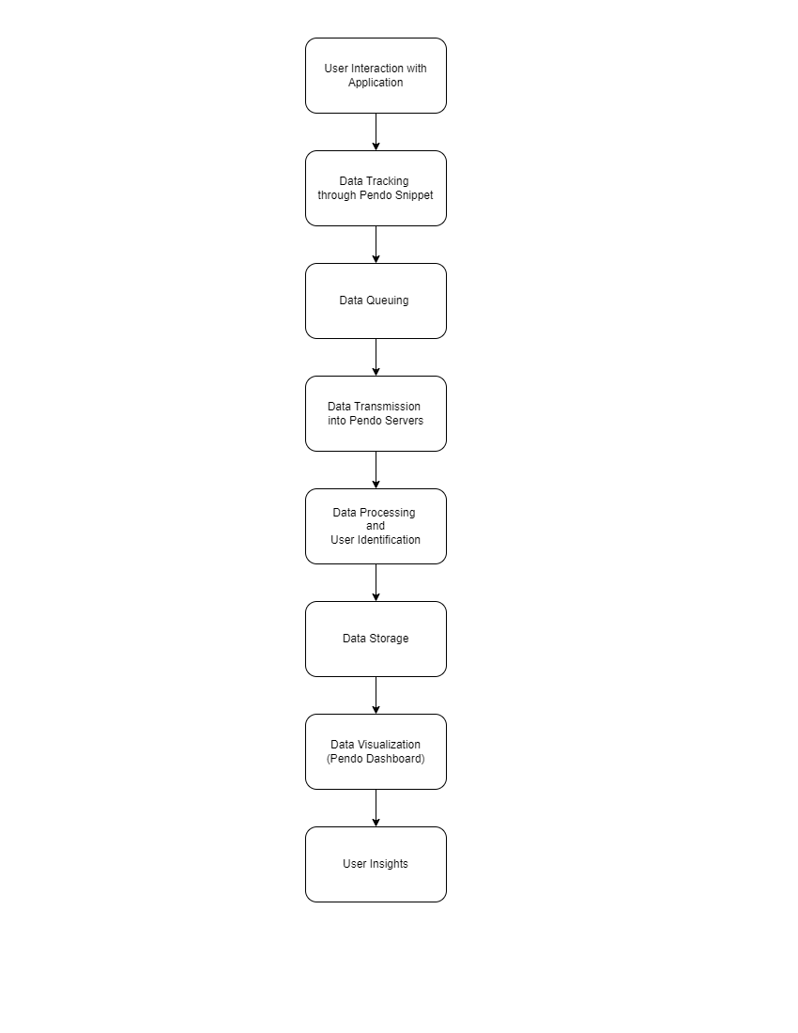

**1. User Interaction with Application:** This represents the initial interaction of users with your web or mobile application. It includes actions such as clicking buttons, submitting forms, viewing pages, and any other interactions within the app.

**2. User Identification:** Pendo associates user interactions with unique identifiers, such as user IDs or cookies, to distinguish individual users. This allows for user-level analysis and segmentation.

**3. Data Tracking** After user interactions, data tracking tools like Pendo's JavaScript library or mobile SDKs record these actions and events. These tools capture what users are doing within the application.

**4. Data Queuing:** The collected data is typically queued or temporarily stored within the application. Queuing helps manage the flow of data and ensures it's ready for transmission.

**5. Data Transmission into Pendo Servers:** Periodically or in real-time, the queued data is sent from the application to Pendo's servers. This transmission typically occurs over a secure connection (e.g., HTTPS).

**6. Data Processing:** Upon receiving the data, Pendo's servers process and validate it. This step may involve checking data integrity, aggregating data points, and preparing it for analysis.

**7. Data Storage:** Processed data is securely stored in Pendo's data infrastructure. This storage ensures data availability and persistence for historical analysis and reporting.

**8. Data Visualization:** Users of the Pendo platform can access the collected and processed data through the Pendo dashboard. The dashboard provides various analytics and reporting tools for visualizing and understanding user behavior.

**9. User Insights:** Organizations can gain insights from the collected data, such as user engagement metrics, conversion rates, and user feedback. Additionally, custom events and feedback surveys can be configured within the Pendo platform to gather additional data and insights from users.

**Please refer the link for any other details on Pendo:**

<https://support.pendo.io/hc/en-us>